Healthcare Operations & Patient Risk Analytics
Executive Report: Emergency Department Waiting Time and ICU Sepsis
Data Analyst Capstone Project | Prepared by Nnadika Sochima Miracle | 20 October 2026

1. Executive Summary
Hospital management asked two questions: why do Emergency Department (ED) patients wait as long as they do, and which ICU patients develop sepsis, a life-threatening reaction to infection, and when. This report analyses 6,000 ED visits (January to September 2025) and 180 ICU patients. Both datasets are synthetic educational datasets, so the findings demonstrate analytical method and are not clinical or operational evidence.

Headline findings
- Urgency drives waiting time. Average waits rise from 5 minutes for the most urgent patients (triage priority 1) to 67 minutes for the least urgent (priority 5). This is triage working as intended.
- Weekends and overnight hours are the pressure points. Weekend visits wait about 15 minutes longer than weekday visits (53.0 vs 37.9 minutes), and the longest waits occur between 11 pm and 5 am. Both periods coincide with fewer staff on duty.
- Staffing is strongly associated with waiting time. Average waits fall from about 64 minutes with 3 staff on duty to about 25 minutes with 16 staff.
- Departments differ even after allowing for urgency. Outpatient - General has the longest waits at every urgency level, and urgent (priority 2) patients wait a median of 19 minutes there against 3 in Emergency.
- Waiting time can be predicted to within about 7 minutes. The best baseline model (Random Forest) explains 84% of the variation in waits; a simple linear model is almost as good.
- Sepsis appears early. Of the 50 patients (27.8%) who developed sepsis, 68% did so within 24 hours of ICU admission and 96% within 48 hours.
- No patient group stood out, and the sepsis models are not usable. Differences by age and gender were within chance. Every model caught only 1 or 2 of the 10 sepsis patients in the test set; 'always predict no sepsis' would be 72.2% accurate, so accuracy alone is misleading.

What we recommend
- Review weekend and overnight staffing rosters against demand, and test whether adding cover shortens waits.
- Review patient flow for urgent patients in Outpatient - General and Surgery Referral, where they wait longer than in Emergency.
- Concentrate sepsis monitoring on the first 24 to 48 hours of an ICU stay.
- Do not use the baseline sepsis models clinically. Collect time-stamped, repeated measurements and larger samples before any prediction tool is built.

2. Business Problem and Objectives
The analytics team was asked to turn raw hospital data into a clear analytical story for a non-technical management audience. Seven business questions guided the work:
# | Business question | Decision it supports
1 | Which departments and triage groups wait longest? | Where to review patient flow
2 | When does waiting pressure build (hour, day type, season)? | Shift and roster planning
3 | How are queue size and staffing related to waiting time? | Whether staffing is an effective lever
4 | Which ICU patient groups develop sepsis more often? | Which groups need closer clinical review
5 | When does sepsis appear during an ICU stay? | When monitoring matters most
6 | Can ED waiting time be predicted from information known at triage? | Short-term staffing and communication
7 | Can sepsis be predicted, and what errors does the model make? | Whether a screening aid is feasible

3. Data and Methods

3.1 Datasets
File | Size | Contents
ED_Waiting_Time_Data.csv | 6,000 x 19 | ED visits, 1 Jan to 27 Sep 2025; five departments; triage priority 1 to 5; staffing, queue size and the minutes spent at each stage
ICU_Sepsis_Patient_Summary.csv | 180 x 6 | Age, gender, ICU length of stay, sepsis outcome and onset hour
ICU_Sepsis_Patient_Data.csv | 180 x 18 | Vital signs, laboratory values and treatments (synthetic, for training)
Data dictionaries (ED and ICU) | - | Owner definitions of each column; used to judge meaning and leakage

3.2 Data audit and cleaning
The raw files were never edited. Every check and change is documented in the notebooks and the decision logs (Appendix). Key points:
- Audit: structure, types, missing values, duplicates, categories, plausibility of minimums, and consistency between visit date, weekday, day type, arrival time and arrival hour. No duplicates, negatives or inconsistencies were found.
- ED: the only gap is 120 missing chief complaints (2%, missing by design per the dictionary). They were labelled 'Unknown' and all 6,000 visits were kept. Visit date was converted to a date type. Summary statistics of all numeric columns are identical before and after cleaning.
- ICU: the 130 blank onset hours belong exactly to the patients without sepsis, so they are not missing data and were never imputed. Thirty blank vital and laboratory values (under 5% of any column) were filled with the training-set median after the train/test split.
- The target variables (waiting time and sepsis outcome) were never imputed, and patient identifiers were never used as predictors.

3.3 Zeros were investigated, not assumed to be missing
A zero is not automatically a missing value. Each zero was investigated and none was changed:
Variable | Zeros | Evidence and decision
arrival_hour | 53 | All fall between 00:00 and 00:58: the midnight hour. Valid; kept.
age | 7 | Counts rise smoothly from age 0 (7, 20, 34, 32...), consistent with infants under one year, but some complaints are unlikely for an infant and the dictionary leaves it open. Kept and flagged (0.1% of rows).
patients_in_queue_at_arrival | 297 | Counts rise smoothly from zero; 69% occur overnight when 5.9% of visits occur. Consistent with an empty queue. Kept.
wait_time_to_provider_minutes | 314 | Mostly triage priority 1 to 2, consistent with immediate care, but only about 20 waits per minute fall just above zero while 314 sit at exactly zero, so a recording floor cannot be excluded. Kept, not imputed (it is the target). Excluding them changes the mean wait from 42.0 to 44.4 minutes and model errors by under 0.2 minutes.

3.4 Modelling approach
- ED (regression): Linear Regression, Decision Tree (depth 5) and Random Forest (100 trees), 80/20 split, scored with MAE, RMSE and R2. Predictors are limited to what is known once triage is complete; total visit time and consultation time (which contain or follow the wait) and patient ID are excluded.
- ICU (classification): Logistic Regression, Decision Tree (depth 3) and Random Forest, stratified 80/20 split, imputation and scaling fitted on the training set only. Excluded: patient ID, onset hour (exists only because of the outcome), length of stay (known at discharge) and the three treatments (timing undocumented).
- Settings are simple baselines with no parameter search, as the brief intends.

4. Emergency Department Findings

4.1 How long do patients wait, and who waits longest?
Waits average 42 minutes (median 42.6), are symmetrical, and 23.3% of patients wait more than an hour. The slowest 10% wait over 72 minutes. A distinct group of about 300 patients is seen almost immediately.
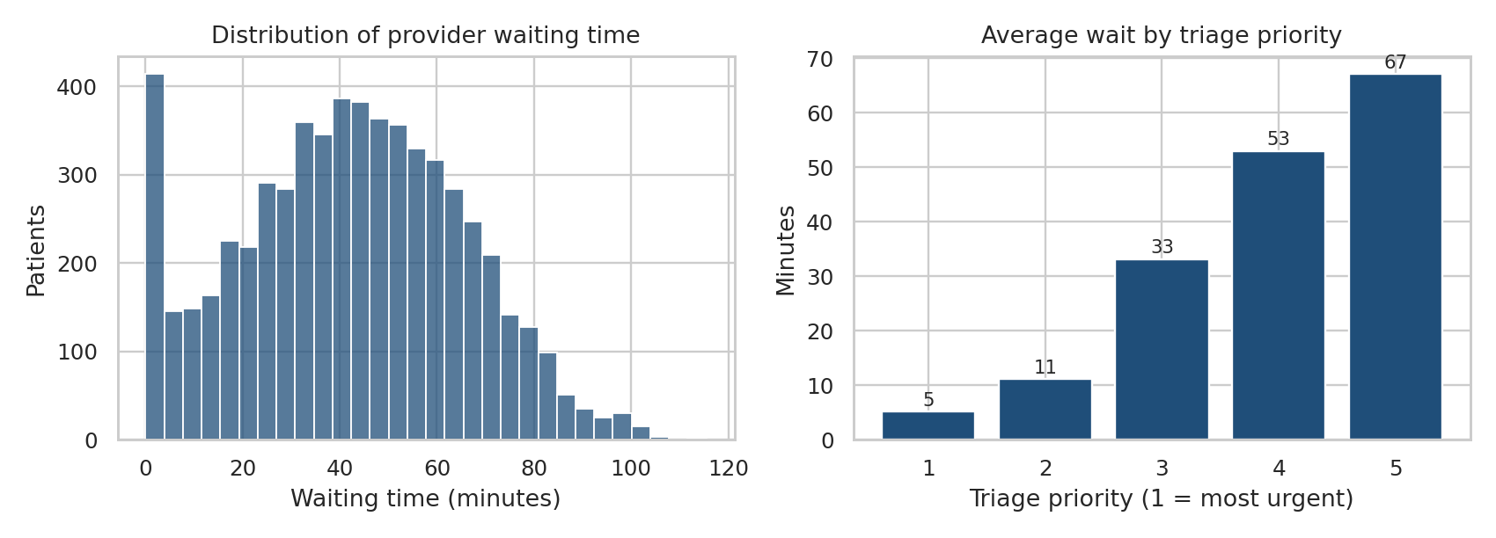
Figure 1. Distribution of provider waiting time (left) and average wait by triage priority (right). Source: ED dataset, 6,000 visits.
Waiting time rises steadily as urgency falls. This ordering is expected, because urgent patients are seen first. It is not itself a performance failure.
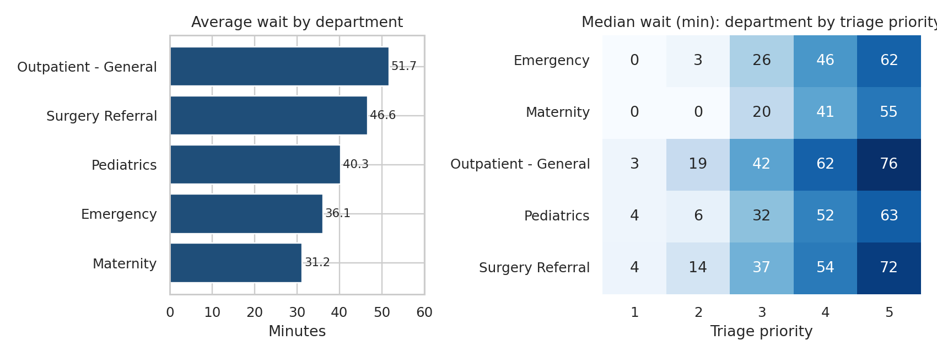
Figure 2. Average wait by department (left) and median wait by department and triage priority (right).
Department | Visits | Mean wait (min) | 90th percentile (min) | Priority 2 median wait (min)
Outpatient - General | 1,818 | 51.7 | 79.8 | 19
Surgery Referral | 629 | 46.6 | 73.0 | 14
Pediatrics | 871 | 40.3 | 69.2 | 6
Emergency | 2,087 | 36.1 | 65.3 | 3
Maternity | 595 | 31.2 | 59.4 | 0

Outpatient - General has the longest waits at priorities 3, 4 and 5. More notably, urgent priority 2 patients wait far longer in Outpatient - General and Surgery Referral than in Emergency or Maternity. This is where flow deserves review. The data cannot say why departments differ.

4.2 When does pressure build, and what is linked to waiting time?
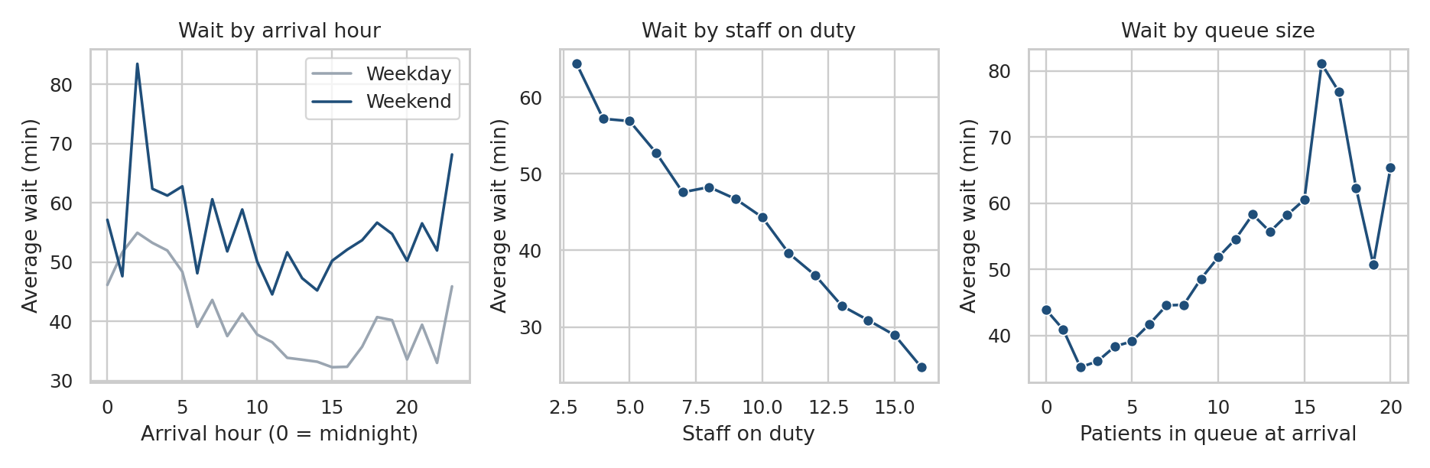
Figure 3. Average wait by arrival hour and day type (left), by staff on duty (centre) and by queue size at arrival (right).
- Weekends: 53.0 minutes against 37.9 on weekdays. The gap holds within every triage priority, so it is not explained by patient mix. Staff on duty averages 8.8 at weekends against 10.7 on weekdays.
- Overnight: waits peak near 60 minutes around 2 am and stay high from 11 pm to 5 am. Overnight hours have few patients (under 90 per hour), so averages there are less stable, and long overnight waits occur with almost no queue, which points to staffing rather than volume.
- Season: essentially flat (41.1, 42.3 and 42.3 minutes). The data covers January to September only, so seasons are partly covered.
- Staffing and queue: correlation with waiting time is -0.28 for staff on duty and +0.20 for queue size, against +0.76 for triage priority. Waits fall steadily from 64 to 25 minutes as staff rise from 3 to 16.
All of these are associations. The data does not prove that adding staff would shorten waits.

4.3 Predicting waiting time
Model | MAE (min) | RMSE (min) | R2
Linear Regression | 7.41 | 9.29 | 0.836
Decision Tree (depth 5) | 8.99 | 11.30 | 0.758
Random Forest | 7.29 | 9.16 | 0.841

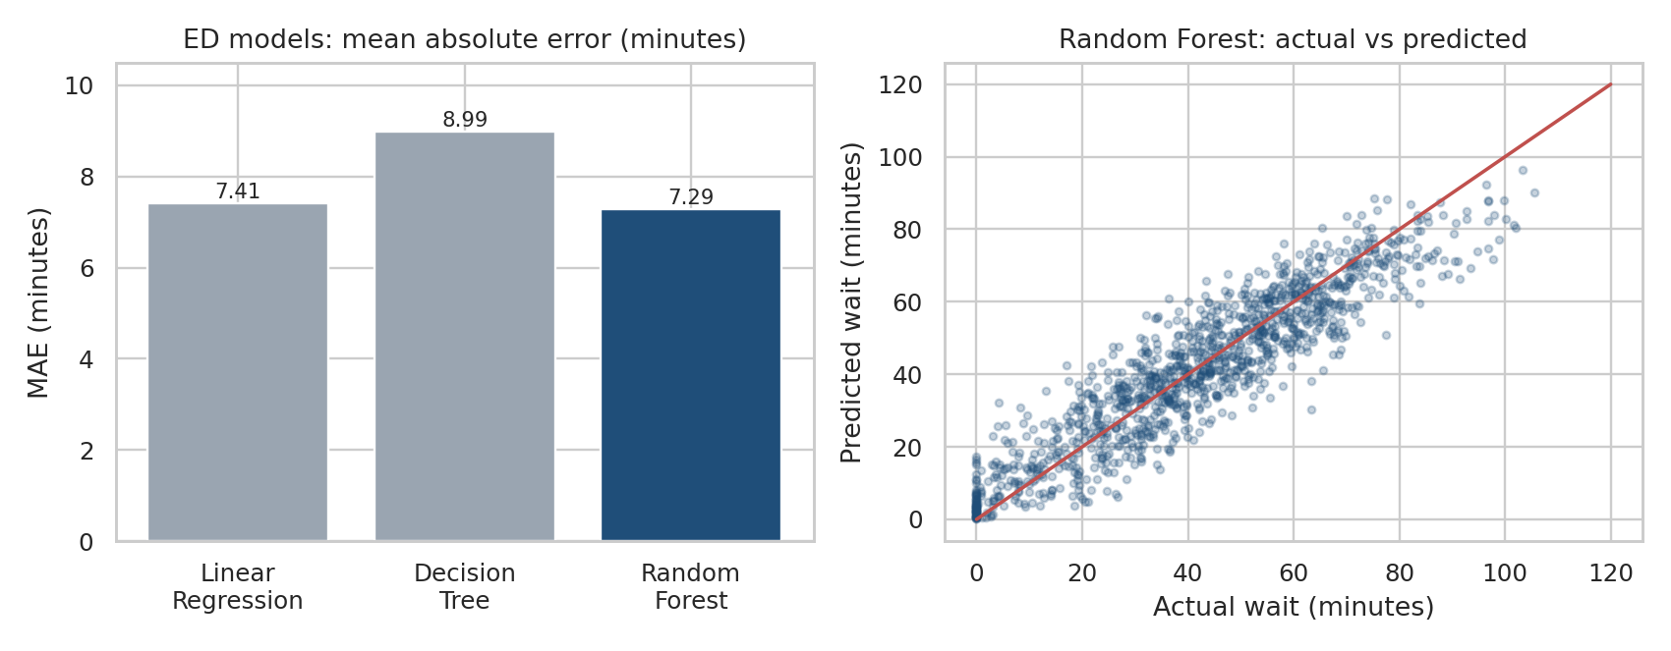
Figure 4. ED model error (left) and Random Forest predictions against actual waits on the test set (right).
In hospital terms: on average a prediction is about 7 minutes from the actual wait (MAE); large misses of 20 minutes or more push the RMSE to about 9; and the model accounts for about 84% of the variation in waits, with the rest due to factors outside the data such as emergencies. The three models are close, and the simple linear model is almost as accurate as the forest. Predictions are weaker for patients seen immediately and slightly low for the longest waits. Linear Regression produced 30 impossible negative predictions (2.5% of the test set), which would be capped at zero in use. Triage priority dominates the forest's importance scores (0.60), followed by weekend arrival, Outpatient - General, queue size and staff on duty.

5. ICU Sepsis Findings

5.1 Who develops sepsis, and when?
Fifty of 180 patients (27.8%) developed sepsis, so the outcome is imbalanced. Sepsis rates did not differ meaningfully by age group (22% to 31%) or gender (26% women, 30% men); none of the differences is distinguishable from chance (p = 0.88 for age group, p = 0.66 for gender), and the groups are small (6 to 22 cases each). Average age was the same in both outcome groups (57 years). ICU stays were longer for patients with sepsis (mean 43.3 against 39.0 hours), but not conclusively (p = 0.13), and since sepsis may itself lengthen a stay, length of stay is an association and not an early predictor.
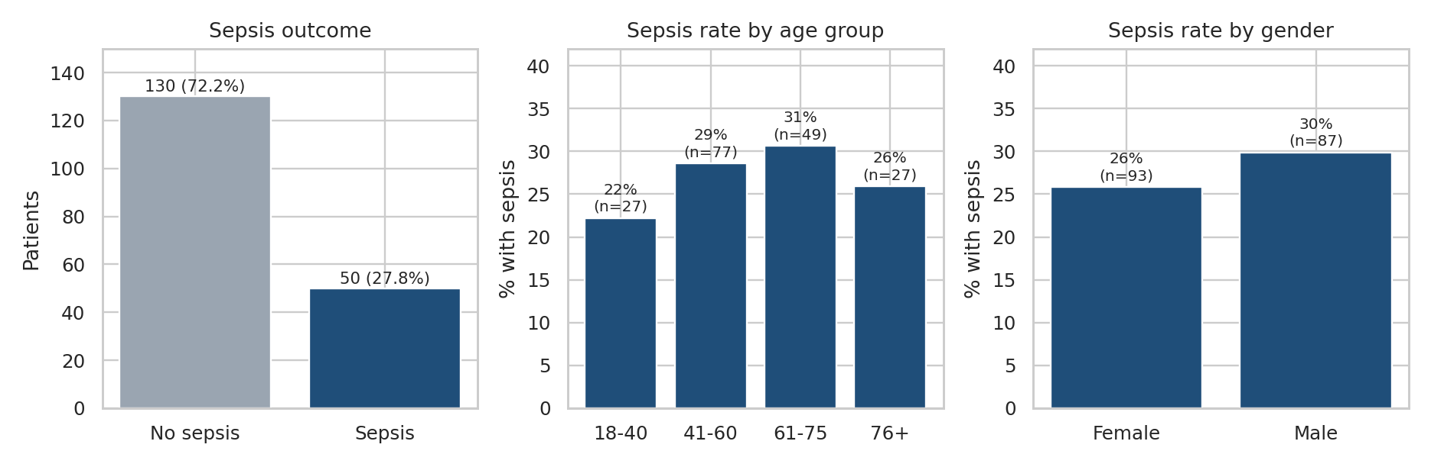
Figure 5. Sepsis outcome distribution (left), and sepsis rate by age group and by gender (centre and right), with group sizes.
Onset time exists only for patients who developed sepsis, so it describes timing and is never used for prediction. Onset ranged from 6 to 51 hours after admission (median 17.5): 34% within 12 hours, 68% within 24 hours and 96% within 48 hours.
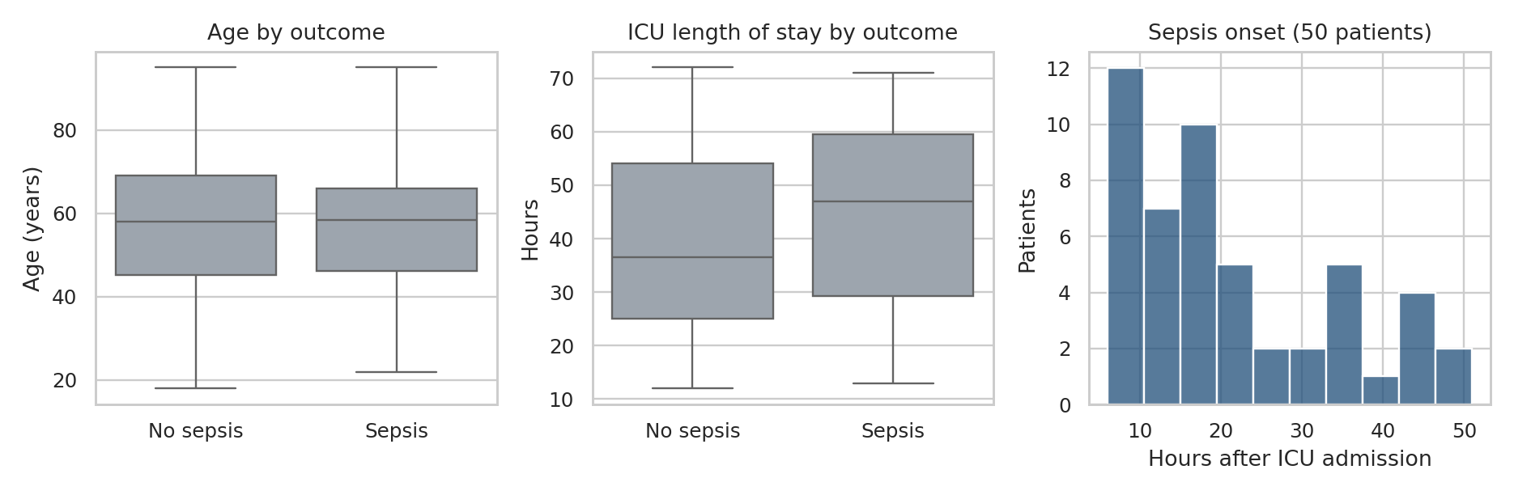
Figure 6. Age and ICU length of stay by outcome, and the timing of sepsis onset among the 50 patients who developed it.

5.2 Predicting sepsis and the cost of errors
Model | Accuracy | Precision | Recall | F1 | ROC-AUC | Missed / caught
Logistic Regression | 0.694 | 0.333 | 0.100 | 0.154 | 0.658 | 9 / 1
Decision Tree (depth 3) | 0.667 | 0.250 | 0.100 | 0.143 | 0.579 | 9 / 1
Random Forest | 0.750 | 0.667 | 0.200 | 0.308 | 0.713 | 8 / 2

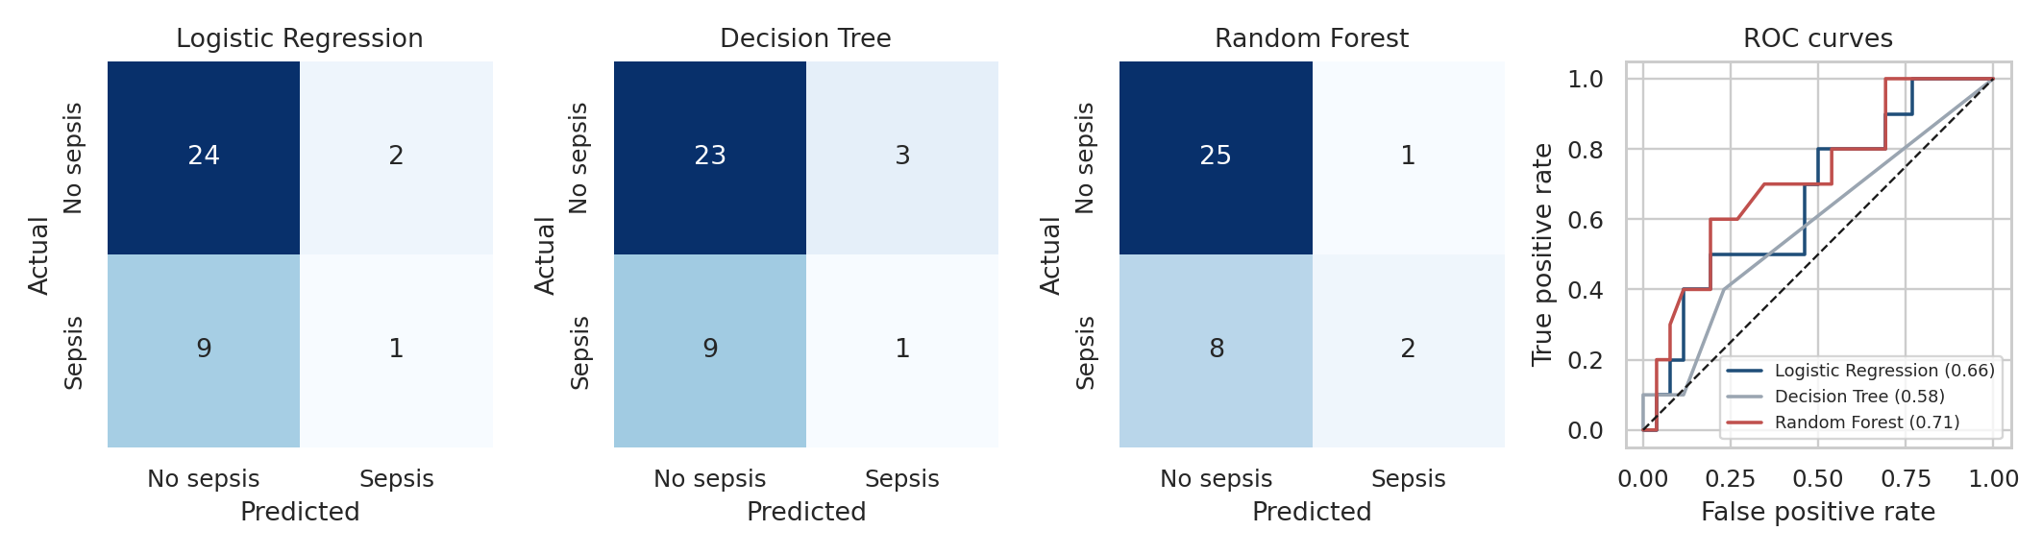
Figure 7. Confusion matrices for each ICU model (rows are actual outcomes, columns are predictions) and ROC curves on the 36-patient test set.
The test set holds 26 patients without sepsis and 10 with sepsis. Accuracy looks respectable, but a model that says 'no sepsis' every time would score 72.2% without catching a single case, so only the Random Forest beat that benchmark, by one patient. The meaningful figure is recall: the models found just 1 or 2 of the 10 septic patients and missed 8 or 9. ROC-AUC (0.58 to 0.71) shows modest discrimination at best.
Why the errors matter. A false negative is a septic patient classed as low risk, so antibiotics may be delayed while sepsis can worsen within hours; this is the more serious error. A false positive is a false alarm that causes extra tests, possible unnecessary antibiotics, workload and, if frequent, alert fatigue. In sepsis screening, recall is therefore prioritised over precision, and by that standard all three models perform poorly.
As a comparison, telling the models to weight sepsis cases more heavily (one setting, not a tuning search) raised recall to 50% for Logistic Regression and 100% for the Decision Tree, but produced many more false alarms (10 and 16 healthy patients flagged) and lowered accuracy to about 56%. Catching more sepsis costs more false alarms, and any real tool would need thresholds agreed with clinicians.
The weak performance is consistent with the exploratory results: the measured variables show little separation between outcome groups. With only 10 sepsis cases in the test set, one patient changes recall by ten percentage points, so differences between models are unreliable and none can be declared better.

6. Recommendations
Recommendation | Evidence | Caution
Review weekend and overnight rostering against demand; pilot extra cover at the busiest weekend and 11 pm to 5 am periods | Weekend waits +15 min; peak near 60 min at 2 am; waits fall from 64 to 25 min as staff rise from 3 to 16 | Association, not proven cause; overnight volumes are small
Review flow for urgent patients in Outpatient - General and Surgery Referral | Priority 2 median wait 19 and 14 min against 3 in Emergency | Reasons for the gap are not in the data
Set expectations for low-urgency patients | Priority 4 to 5 average 53 to 67 min; 23% of all patients wait over an hour | Long low-urgency waits are partly by design
Focus sepsis monitoring on the first 24 to 48 hours of ICU stay | 68% of onsets within 24 h, 96% within 48 h | 50 cases, synthetic data
Do not deploy the baseline sepsis models | Recall 10% to 20%; no model beat the 72.2% benchmark | A future tool needs larger, time-stamped data and clinician-set thresholds
Use the ED waiting-time model only as a planning aid | MAE about 7 min; R2 0.84 | Single hospital, synthetic data, one split
Document how waiting time is recorded | 314 zero waits cannot be classed as immediate care or a recording convention | Resolve with the data owner

7. Limitations and Assumptions
- Both datasets are synthetic educational datasets; results illustrate method and are not clinical or operational evidence.
- ED data covers January to September 2025 only; the Harmattan/Dry season is partly covered. The ICU sample is 180 patients with 50 sepsis cases, and the test set holds only 10.
- The 314 zero waits may reflect immediate care or a recording floor; Maternity includes male patients (311), which is unrealistic; 7 patients aged 0 are plausible infants but some complaints are unlikely.
- The ICU data has no timestamps, so the assumption that vitals and labs precede sepsis onset cannot be verified. Clinical values are mild and narrow in range. Treatments and length of stay were excluded because their timing relative to sepsis is unknown.
- Missing ICU values were filled with a simple median baseline; in real data, missingness can itself be informative. One train/test split, no cross-validation and no parameter search were used, by design.
- All findings are associations. No causal claims are made.

Appendix A. Decision Logs

ED decision log
ID | Decision | Rationale
D01 | 120 missing chief complaints labelled 'Unknown'; rows kept | Text column, not the target; avoids deleting 2% of visits
D02 | 314 zero waits kept, not imputed; sensitivity run without them | Plausible immediate care but a possible floor; calculation undocumented; conclusions unchanged
D03 | 311 male patients in Maternity kept; noted as a limitation | Unrealistic pattern; avoid conclusions about department and gender
D04 | visit_date converted to datetime on the working copy | Needed for date analysis; raw data unchanged
D05 | patient_id, total_visit_duration, consultation_duration excluded from features | Identifier; contains the target; occurs after the wait
D06 | ED modelled as regression only | Matches the brief; avoids an arbitrary threshold; classification covered in ICU
D07 | 11 features used; visit_date, day_of_week, arrival_time, chief_complaint excluded | Duplicate information or kept out for a simple baseline
D08 | 30 negative linear predictions reported, not altered | Waits cannot be negative; would be capped at zero in practice
D09 | 53 zeros in arrival_hour kept | Midnight hour confirmed from arrival_time
D10 | 7 zeros in age kept and flagged | Plausible infants; dictionary leaves it open; 0.1% of rows
D11 | 297 zeros in queue size kept | Plausible empty queue, mostly overnight; smooth distribution

ICU decision log
ID | Decision | Rationale
I01 | 130 blank onset hours not imputed; never a feature | Blank means no sepsis; exists only because of the outcome
I02 | 30 missing vital and lab values filled with training-set medians after the split | Under 5% per column; prevents leakage; target never imputed; advanced methods out of scope
I03 | Files merged on patient_id, one copy of shared columns kept | Age, gender and length of stay verified identical
I04 | patient_id, onset hour, length of stay and treatments excluded from features | Identifier; outcome-derived; known at discharge; treatment timing undocumented
I05 | Vitals and labs assumed measured before onset | No timestamps in data or dictionary; recorded as a limitation
I06 | Stratified train/test split | 27.8% positive outcomes
I07 | Age bands created (18-40, 41-60, 61-75, 76+) before viewing results | For group comparison; raw data unchanged
I08 | 13 features used for modelling | Excludes identifiers, outcome-derived and post-outcome variables
I09 | Default baseline settings; one class-weight comparison; no parameter search | Brief asks for baselines; weighting illustrates the false-negative trade-off

Reproducibility
The repository contains the raw data (unchanged), cleaned data, two notebooks (01_ED_Analysis.ipynb and 02_ICU_Sepsis_Analysis.ipynb), the Power BI dashboard, this report, and a requirements file. Notebooks run top to bottom after the raw CSV files are uploaded to the working folder.

